## Week 6 – 1:

## ROLL NO.:241801042

## Name: P.DARSSHINI



Q1In this challenge, we're going to use loops to help us do some simple math. Check out the Tutorial tab to learn more.

Task

Given an integer, n, print it's first 10 multiples. Each multiple n X i (where 1 ≤ i ≤ 10) should be printed on a new line in the form: n x i = result.

Input Format

A single integer, n.

Constraints

2 ≤ n ≤ 20

Output Format

Print 10 lines of output; each line i (where 1 ≤ i ≤ 10) contains the result of n X i in the form:

n x i = result.

Sample Input

2

Sample Output

2 x 1 = 2

2 x 2 = 4

2 x 3 = 6

2 x 4 = 8

2 x 5 = 10

2 x 6 = 12

2 x 7 = 14

2 x 8 = 16

2 x 9 = 18

2 x 10 = 20

Code:

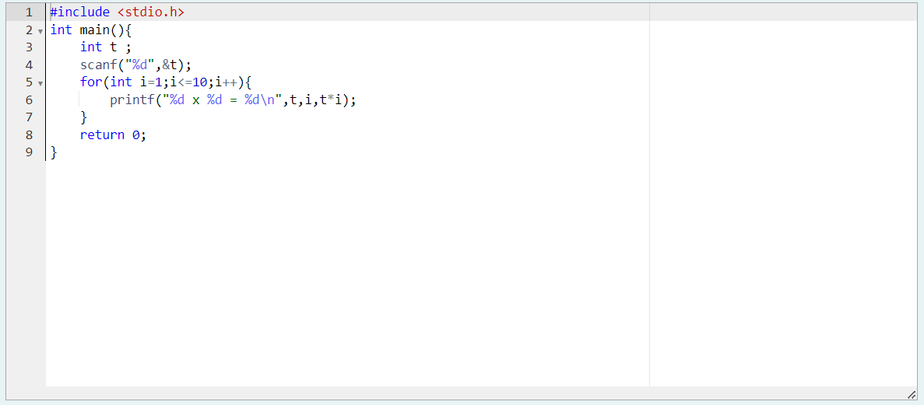

OUTPUT:



Q2) A nutritionist is labeling all the best power foods in the market. Every food item arranged in a single line, will have a value beginning from 1 and increasing by 1 for each, until all items have a value associated with them. An item's value is the same as the number of macronutrients it has. For example, food item with value 1 has 1 macronutrient, food item with value 2 has 2 macronutrients, and incrementing in this fashion.

The nutritionist has to recommend the best combination to patients, i.e. maximum total of macronutrients. However, the nutritionist must avoid prescribing a particular sum of macronutrients (an 'unhealthy' number), and this sum is known. The nutritionist chooses food items in the increasing order of their value. Compute the highest total of macronutrients that can be prescribed to a patient, without the sum matching the given 'unhealthy' number.

Here's an illustration:

Given 4 food items (hence value: 1,2,3 and 4), and the unhealthy sum being 6 macronutrients, on choosing items 1, 2, 3 -> the sum is 6, which matches the 'unhealthy' sum. Hence, one of the three needs to be skipped. Thus, the best combination is from among:

·         2 + 3 + 4 = 9

·         1 + 3 + 4 = 8

·         1 + 2 + 4 = 7

Since 2 + 3 + 4 = 9, allows for maximum number of macronutrients, 9 is the right answer.

Complete the code in the editor below. It must return an integer that represents the maximum total of macronutrients, modulo 1000000007 (109 + 7).

It has the following:

    n: an integer that denotes the number of food items

    k: an integer that denotes the unhealthy number

Constraints

·         1 ≤ n ≤ 2 × 109

·         1 ≤ k ≤ 4 × 1015

Input Format For Custom Testing

The first line contains an integer, n, that denotes the number of food items.

The second line contains an integer, k, that denotes the unhealthy number.

Sample Input 0

2

2

Sample Output 0

3

Explanation 0

The following sequence of n = 2 food items:

1.      Item 1 has 1 macronutrients.

2.      1 + 2 = 3; observe that this is the max total, and having avoided having exactly k = 2 macronutrients.

Sample Input 1

2

1

Sample Output 1

2

Explanation 1

1.      Cannot use item 1 because k = 1 and sum ≡ k has to be avoided at any time.

2.      Hence, max total is achieved by sum = 0 + 2 = 2.

Sample Case 2

Sample Input For Custom Testing

Sample Input 2

3

3

Sample Output 2

5

Explanation 2

2 + 3 = 5, is the best case for maximum nutrients.

Code:

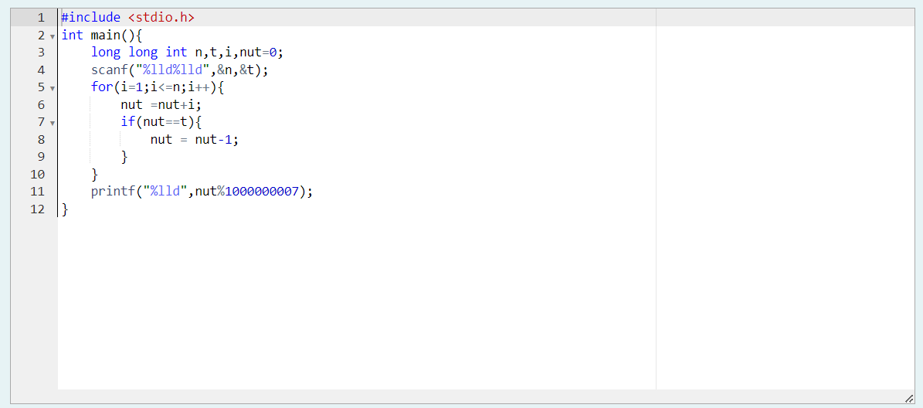

OUTPUT:



Q3) Determine all positive integer values that evenly divide into a number, it's factors. Return the pth element of your list, sorted ascending. If there is no pth element, return 0.

For example, given the number n = 20, it's factors are {1,2,4,5,10,20}. Using 1-based indexing if p = 3, return 4. If p > 6, return 0.

Complete the code in the editor below. The function should return a long integer value of the pth integer factor of n.

It has the following:

    n:  an integer

    p:  an integer

Constraints

·         1 ≤ n ≤ 1015

·         1 ≤ p ≤ 109

Input Format for Custom Testing

Input from stdin will be processed as follows and passed to the function.

The first line contains an integer n, the number to factor.

The second line contains an integer p, the 1-based index of the factor to return.

Sample Input 0

10

3

Sample Output 0

5

Explanation 0

Factoring n = 10 we get {1, 2, 5, 10}. We then return the p = 3rd factor as our answer.

Sample Input 1

10

5

Sample Output 1

0

Explanation 1

Factoring n = 10 we get {1, 2, 5, 10}. There are only 4 factors and p = 5. We return 0 as our answer.

Sample Input 2

1

1

Sample Output 2

1

Explanation 2

Factoring n = 1 we get {1}. We then return the p = 1st factor as our answer.

Code:

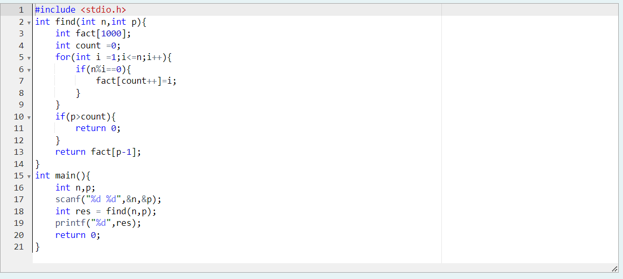

OUTPUT:

